This tip sheet describes the critical elements and workflow when the bedside nurse encounters the SIRS and Severe Sepsis BPA.
SIRS BPA
This alert will fire as an early warning for patients who are exhibiting specific vital signs that have been linked to the early stages of sepsis. The nurse will see the alert on entering the patient’s chart. Patients must have 2 of the following vital signs to trigger the alert:
- HR >100 | - Temp >38.3^{C} and <35.5^{C} | - RR >23 | - WBC <4 and >12.5
This is the alert that the Bedside RN will see:

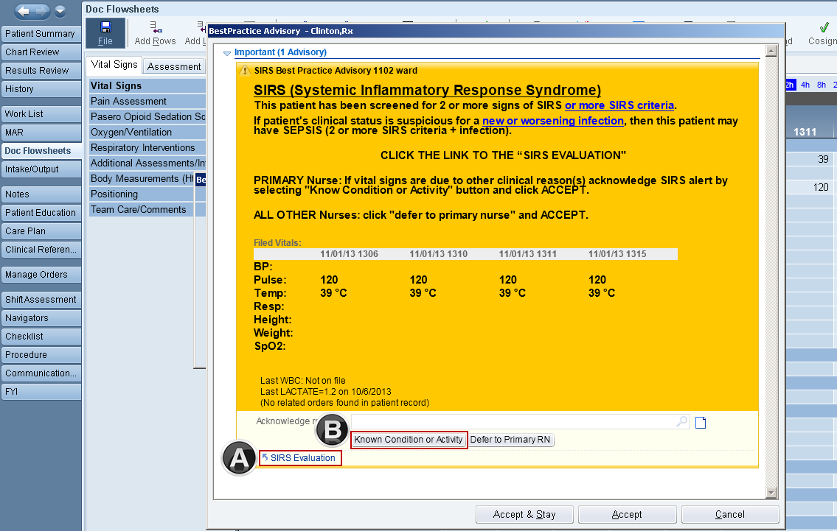

If primary nurse suspects the patient has a new or worsening infection, click the ‘SIRS evaluation” link. This links out to a navigator to answer questions about source of infection and order a lactate (if needed), using the Lactate Nursing Procedure.
If the vital signs and/or organ dysfunction present are due to another clinical process (activity, treatment, pain or anxiety) or the patient is Palliative Care click ‘Known Condition or Activity’. The alert will be suppressed for 4 hours. The nurse’s clinical judgement must be used if a patient shows signs of worsening condition during the lock out times to alert the appropriate provider.
The Cancel button should only be used for medication administration, blood administration, and patient emergencies.
SIRS Evaluation Navigator:
When the ‘SIRS Evaluation’ link is selected it opens a navigator which includes:
- Questions on infection and source to evaluate for sepsis
- Lactate order status: presence of an active lactate order or if there is lactate order resulted within last 4 to 24 hrs.
- Lactate order
- Use the Sepsis VS/Lab Data tab on the left of the navigator to see ID/Sepsis Flowsheet with all pertinient information.
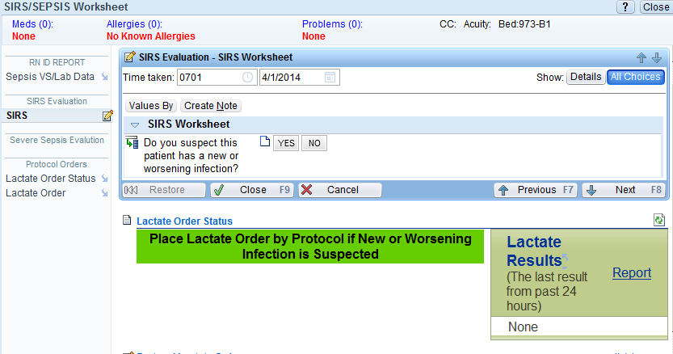

If new or worsening infection is suspected, evaluate the need to enter a lactate order.
Example: there is an active lactate order, another order does not need to be placed.
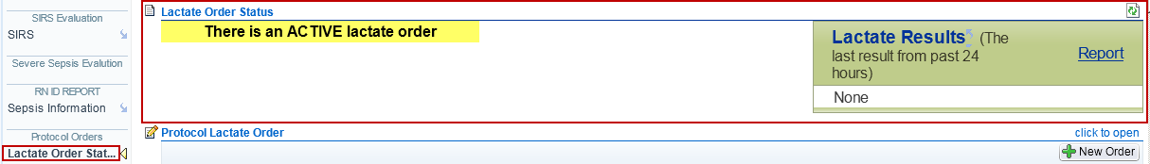
Example: a lactate order needs to be placed.
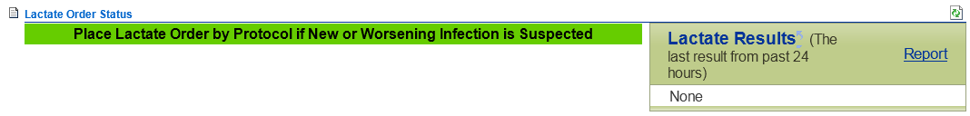

If a lactate needs to be ordered use the Lactate Order section.
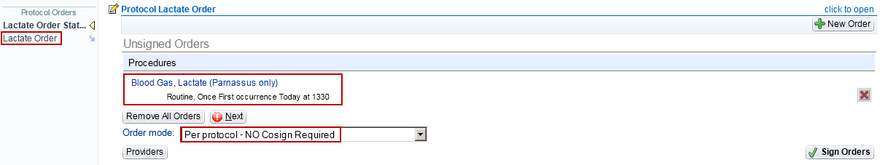

Lactates are to be drawn up in a blood gas syringe (arterial or venous blood can be sent).
Lactates should be drawn immediately after a tourniquet is placed and should be the first specimen drawn if drawing more than one specimen.

Patient List Column:
After a SIRS Alert has fired a yellow star will display in the SIRS/SEVERE SEPSIS patient list column. The star will display until the nurse acknowledges the alert. The column needs to be ‘wrenched in’.
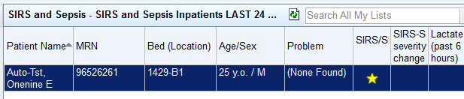

Severe Sepsis BPA:
The Severe Sepsis BPA will fire when there are 2 signs of SIRS documented and evidence in the documentation of one end organ failure criteria. The nurse will see the alert on entering the patient’s chart.

End Organ Failure includes:
- SBP <90, MAP <65
- Level of Consciousness documented as difficult to maintain arousal, somulent, lethargic, obtunded, disoriented, and responding to pain only (excluded in ICU sedated patients)
- Lactate >2
- SpO2 <89% in ICU; <92% in acute care
- INR >1.5 (excluded when orders for warfarin and argatroban are present)
- PTT >60 (excluded when orders for heparin and argatroban infusions are present)
- Tbili >4
- Platelets <100
- Creatinine >2.0 in last 24 hours (omits if ESRD is in problem list)
- The alert will look like this:
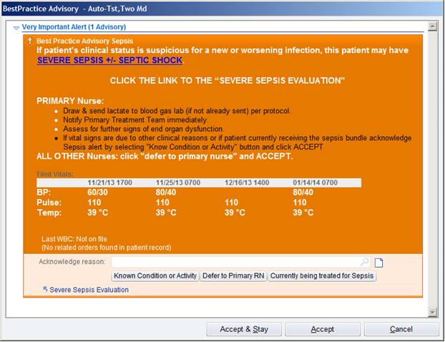
When this BPA fires, notify Primary team immediately to relay clinical information of the patient.
If the vital signs and/or organ dysfunction present are due to another clinical process (activity, treatment, pain or anxiety) or the patient is Palliative Care click ‘Known Condition or Activity’. The alert will be suppressed for 4 hours, therefore clinical judgement must be used with signs of worsening condition during lock out to alert the appropriate provider.
For patients who are currently being treated or have received ALL of the Sepsis Bundle elements within the previous 24 hours click ‘Currently being treated for Sepsis’. Locks out the alert for 12 hrs.
If the primary nurse suspects the patient has a worsening infection along with these organ failures, click on the ‘Severe Sepsis Evaluation’ link, he/she will be prompted to click on the Code Sepsis button in the Severe Sepsis Navigator.
The Cancel button should only be used for medication administration, blood administration, and patient emergencies.
Severe Sepsis Evaluation Navigator:
- Do you suspect the patient has a new or worsening infection? If yes, then activate Code Sepsis to page the Code Sepsis team to come to the bedside. The Primary Team must also be notified.
- Use the Sepsis VS/Lab Data tab on the left of the navigator to see ID/Sepsis Flowsheet with all pertinient information.
- If there is no identifiable source of infection, choose that option to silence the alert for 12 hours.
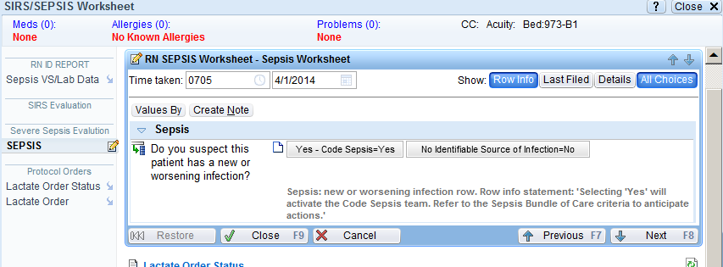
Patient List Column:
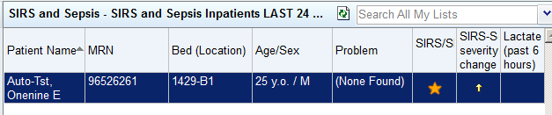
After a Severe Sepsis Alert has fired an orange star will display in the SIRS/SEVERE SEPSIS patient list column. This star will display until the nurse acknowledges the alert. This star may turn gray if the provider assessed the patients clinical course is not due to sepsis The column needs to be ‘wrenched in’.
After selecting ‘Code Sepsis’ the Code Sepsis Alert will display:
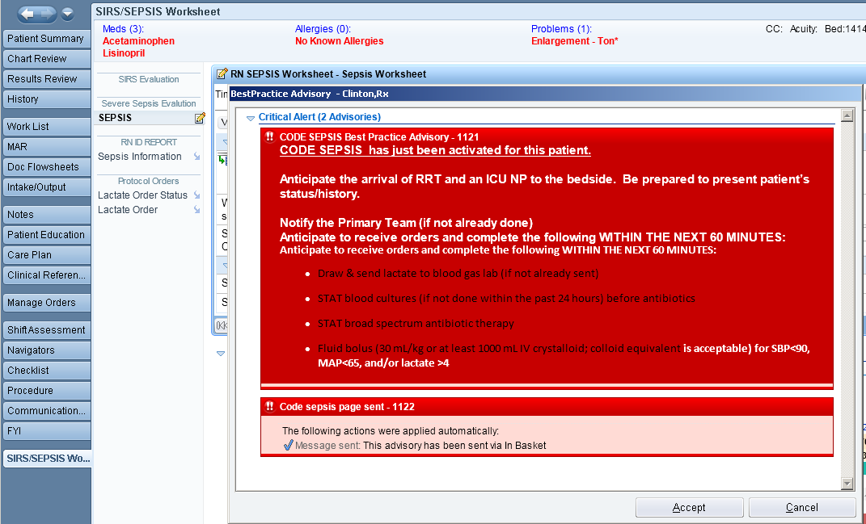
The Code Sepsis Alert goes out to the ICU NP and RRT team, who will respond. The Primary team MUST be alerted that a code sepsis has been called. Pharmacy is linked to the Code Sepsis Page and will follow up with the RN and/or RRT by phone.
The bedside nurse should be prepared to present the patient’s condition and be ready to implement the Sepsis Bundle Elements:
- Lactate
- Blood cultures
- Antibiotics
- Fluid bolus for lactate >4 and /or SBP <90.
Patient List Column:

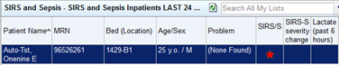

After a Code Sepsis is paged a red star will display in the SIRS/SEVERE SEPSIS column on the patient list column. This star will be present for 24 hours after provider confirmation of the Code Sepsis, or may turn gray if provider assessed the patients clinical course is not due to sepsis. The column needs to be ‘wrenched in’. No alerts will fire for 24 hours after the patient has had a Code Sepsis initiated. If the patient remains outside of the ICU, the nurse will need to notify RRT by pagerbox if the patient’s condition worsens.

Patient list column ‘Star’ review:

- Yellow (SIRS only): Disappears after two hours if signs of SIRS go back to normal values. Stays yellow if patient continues to exhibit signs of SIRS.
- Orange (SIRS plus organ failure): Stays orange for 12 hours or until provider interacts with it.
- Red (code sepsis): Stays red for 24 hours independent of what the patient’s vital signs are.
- Gray (provider deems vital signs are not NEW sepsis): Stays for 24 hours from the time of provider interaction.

